**Cooperation agreement signed with German Federal Railway Authority**

**9Apr**2019

The President of the Eisenbahn-Bundesamt (EBA) Gerald Hörster and ERA’s Executive Director, Josef Doppelbauer signed a cooperation agreement between the European Union Agency for Railways and the German Federal Railway Authority.

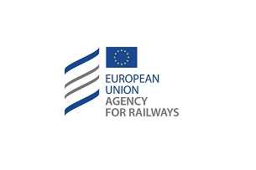

The agreement establishes the conditions under which the two authorities are expected to cooperate in relation to the ERA’s and EBA’s new tasks of issuing single safety certificates, vehicle and vehicle type authorisations, as well as the framework of EBA’s assistance to ERA.

The signature inaugurates a new cooperation era for the Agency and the National Safety Authorities and is expected to enhance the practical implementation 4th Railway Package.

This was the first cooperation agreement signed between the Agency and a National Safety Authority of the EU.

The Agency is expected to sign more cooperation agreements with the other National Safety Authorities of the Single European Railway Area prior to taking up its new responsibilities.